AWS Setup Steps

Steps for setting up fraud detector data in AWS console.

Sign up for AWS Fraud Detector Account
Go here, https://aws.amazon.com/fraud-detector/
Follow ‘Get Started with Amazon Fraud Detector’ steps.

Variables
Go to AWS Console > Fraud Detector service. Under Resources > Variables we will add all necessary variables.

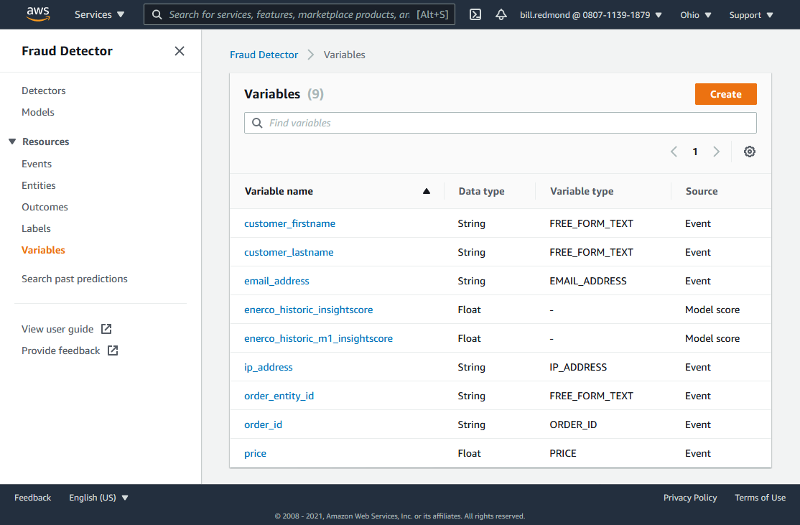

Variables that are part of the model data upload.
Variable name | Data type | Variable type | Source
customer_firstname | String | FREE_FORM_TEXT | Event
customer_lastname | String | FREE_FORM_TEXT | Event
email_address | String | EMAIL_ADDRESS | Event
enerco_historic_insightscore | Float | - | Model score
enerco_historic_m1_insightscore | Float | - | Model score
ip_address | String | IP_ADDRESS | Event
order_entity_id | String | FREE_FORM_TEXT | Event
order_id | String | ORDER_ID | Event
price | Float | PRICE | Event

Additional variables that will be sent from Magento to AWS
Variable name | Data type | Variable type | Source | Required
billing_address_1 | String | BILLING_ADDRESS_L1 | Event | Yes
billing_city | String | BILLING_CITY | Event | Yes
billing_country | String | BILLING_COUNTRY | Event | Yes
billing_name | String | BILLING_NAME | Event | Yes
billing_phone_number | String | BILLING_PHONE | Event | Yes
billing_state | String | BILLING_STATE | Event | Yes
billing_zip | String | BILLING_ZIP | Event | Yes
credit_card_type | String | CATEGORICAL | Event
currency_code | String | CURRENCY_CODE | Event | Yes
event_timestamp | String | EVENT_TIMESTAMP | Event | No
payment_instrument_type | String | PAYMENT_TYPE | Event | ?
phone_number | String | PHONE_NUMBER | Event | Yes
shipping_address_1 | String | SHIPPING_CITY | Event | Yes
shipping_city | String | SHIPPING_CITY | Event | Yes
shipping_country | String | SHIPPING_COUNTRY | Event | Yes
shipping_name | String | SHIPPING_NAME | Event | Yes
shipping_phone_number | String | SHIPPING_PHONE | Event | Yes
shipping_state | String | SHIPPING_STATE | Event | Yes
shipping_zip | String | SHIPPING_ZIP | Event | Yes
site_id | String | FREE_FORM_TEXT | Event | No
total_order_price | Float | PRICE | Event | Yes/No
user_agent | String | USERAGENT | Event | Yes
user_id | String | FREE_FORM_TEXT | Event | No
user_name | String | FREE_FORM_TEXT | Event | No

Labels
Go to AWS Console > Fraud Detector service. Under Resources > Labels we will add all necessary labels.

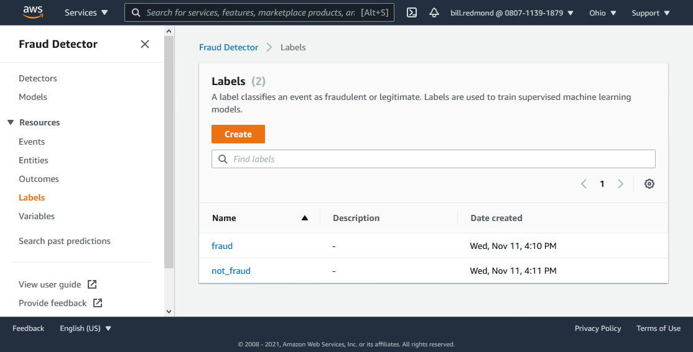

Labels that are part of the model data upload.
Name | Description | Date created
fraud | - | Wed, Nov 11, 04:10 PM
not_fraud | - | Wed, Nov 11, 04:11 PM

Outcomes
Go to AWS Console > Fraud Detector service. Under Resources > Outcomes we will add all necessary outcomes.

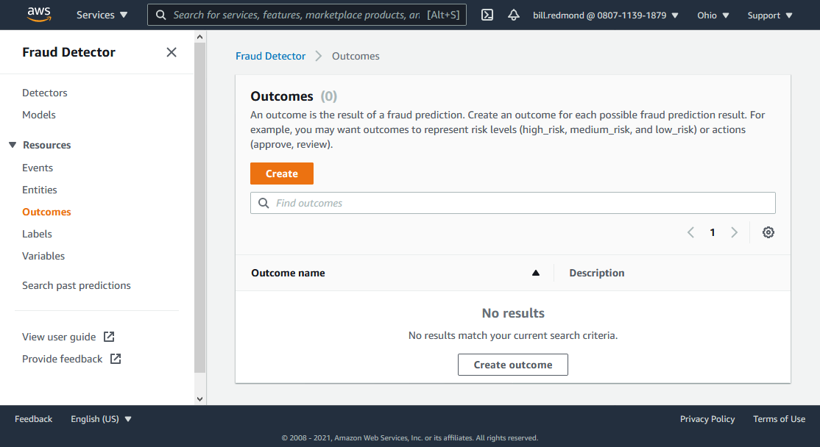

Outcomes that will be sent from Magento to AWS
Outcome name | Description
review_order | Orders will be put on hold in Magento admin and can be reviewed and approved by admin user.
cancel_order | Order has a bad score and will be automatically canceled.

Entities

Go to AWS Console > Fraud Detector service. Under Resources > Entities we will add all necessary entities.

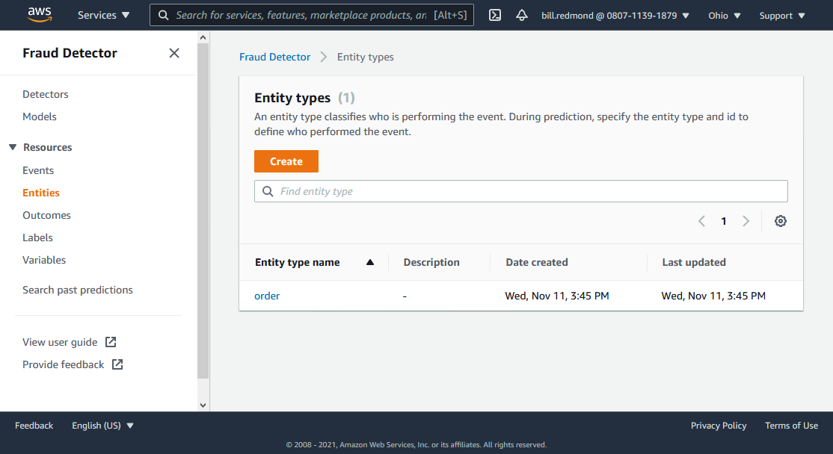

Entities that are part of the model data upload.
Entity type name | Description | Date created | Last updated
order | - | Wed, Nov 11, 03:45 PM | Wed, Nov 11, 03:45 PM

Events

Go to AWS Console > Fraud Detector service. Under Resources > Events we will add all necessary events.

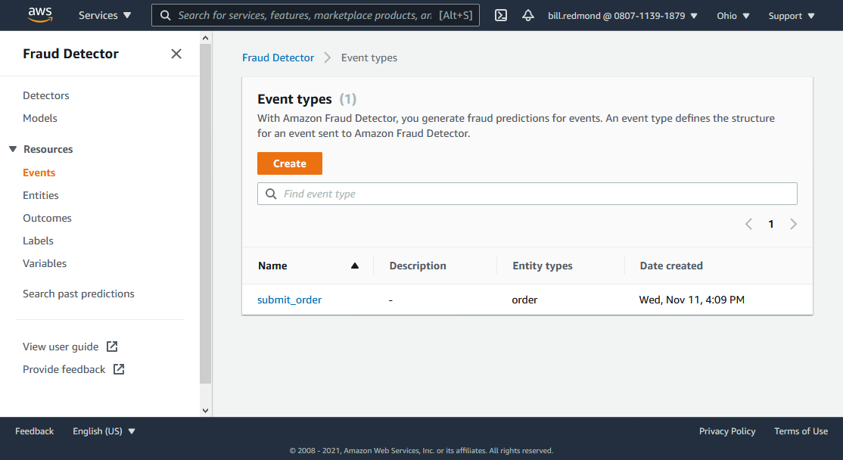

Events that are part of the model data upload.
Name | Description | Entity types | Date created
submit_order | - | order | Wed, Nov 11, 04:09 PM

Models
Go to AWS Console > Fraud Detector service. Under Models we add models.

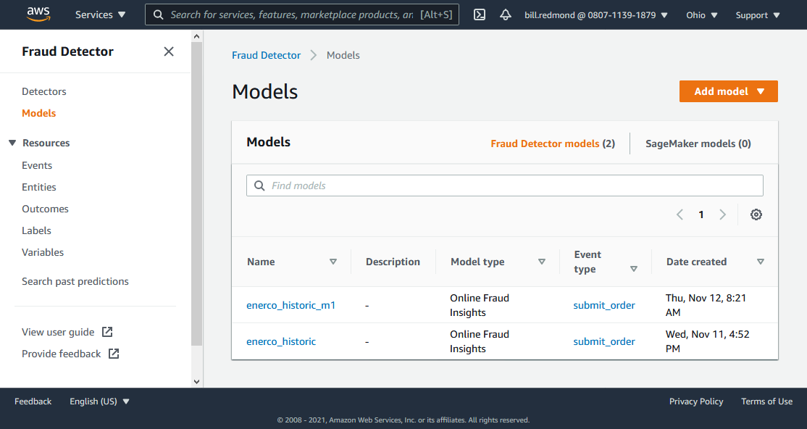

Models we have created as part of the data upload.
Name | Description | Model type | Event type | Date created
enerco_historic_m1 | - | Online Fraud Insights | submit_order | Thu, Nov 12, 08:21 AM
enerco_historic | - | Online Fraud Insights | submit_order | Wed, Nov 11, 04:52 PM

Detector and Rules

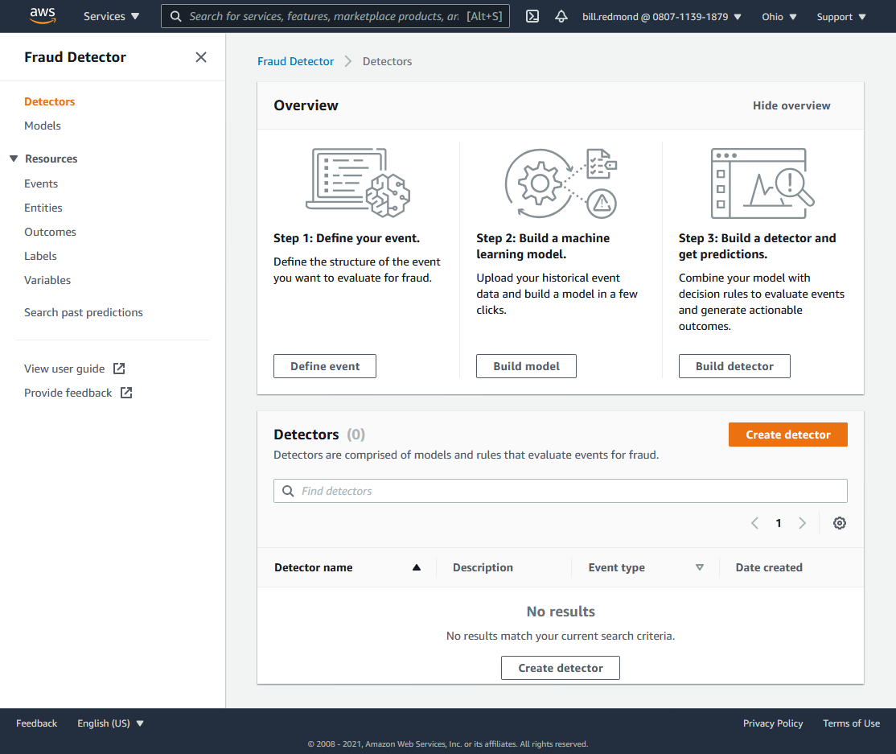

Detector we will configure

Detector name | Description | Event type | Date created
enerco_submit_order | - | submit_order | Mon, Aug 17, 01:25 PM

Detector we associate with the detector
1 | cancel | - | Score above cancel threshold | cancel_order
2 | review | - | Score between review and cancel thresholds | review_order

